Homework 4 Report

Wyatt Duberstein

Implementation:

Honestly, my implementation is pretty shoddy as this is my first time working with React, along with me still being an amateur at JavaScript. I made a few simple functions that can do the required designing of the interface, the sorting of the data by year, and the incrementing of the stock at the push of the button. Here are a few screenshots of the resulting outputs of my program:

This is what it looks like upon loading in the index.html in a web browser:

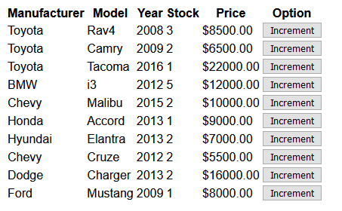

Here is the output after one press of the “Year” Button:

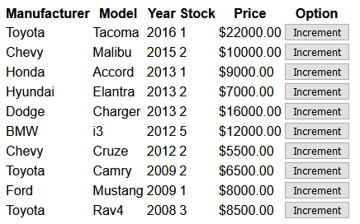

Another Press of the “Year” Button:

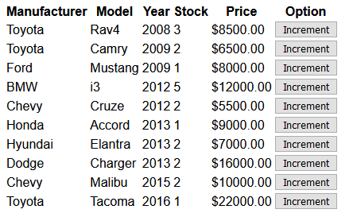

From here, it only alternates between the last 2 screenshots upon repeated pressing of the “Year” button.   
  
Here is a screenshot after pressing the first increment button:

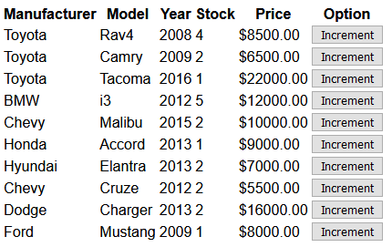

As you can see, the stock for the Rav4 has increased from 3 to 4.

Here is me randomly pressing all of the increment buttons, just for good measure:

